A.MOHAMMED THARICK
+91-9176363858 | mdtharick25@gmail.com | https://www.linkedin.com/in/mdtharick/

Objective

Motivated and detail-oriented B.Sc Artificial Intelligence student with hands-on experience in web development, database systems, and software project implementation . Skilled in front-end and back-end Technologies, with strong analytical and communication abilities Eager to contribute to team success through problem solving, collaborations, and innovations.

Education

- B.Sc - Artificial Intelligence
Dhanalakshmi Srinivasan College | 2022 - 2025
CGPA: 7.4

- Higher Secondary Certificate
Mary's Matriculation Higher Secondary School | 2020 - 2021
Percentage: 69%

Work Experience
Machine Learning Intern
VCodez – Innovating Ideas
Jan 2025 – Apr 2025
- Built and fine-tuned ML models for classification, regression, and clustering tasks.
- Tuned hyperparameters and engineered features, resulting in better-performing models across multiple use cases.
- Ran model comparisons and documented results.
- Assisted in deploying models to production and monitoring their performance.
Projects
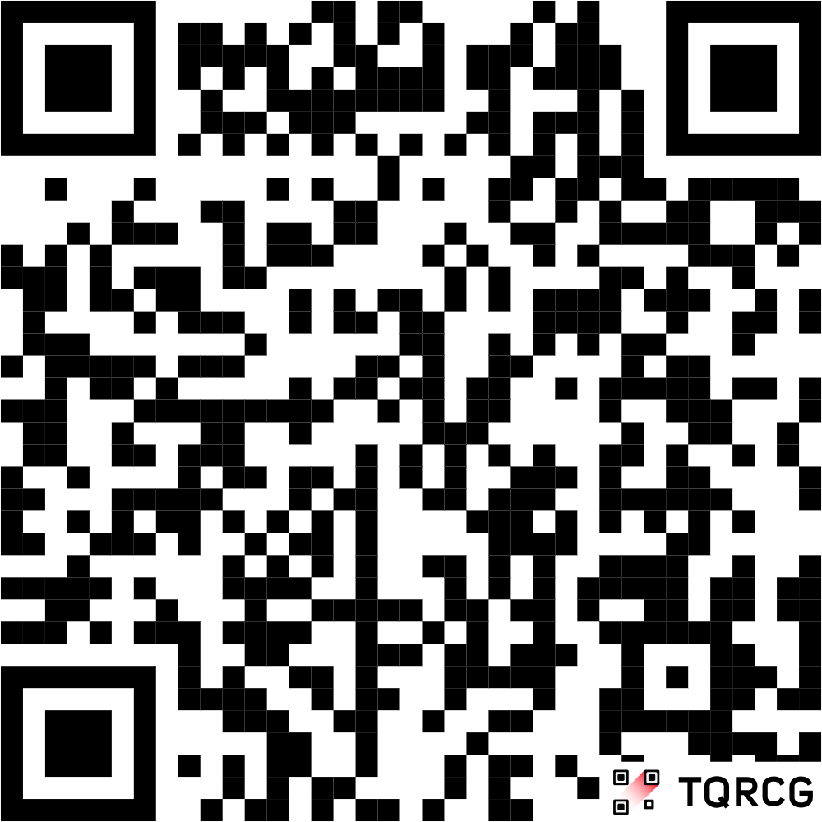
Solo Leveling System

Technologies Used: React, Node.js
Scan Me!

- Developed a gamified system inspired by the Solo Leveling universe. Implemented dynamic quest features, character progression, and backend API calls. Enhanced performance and ensured responsiveness.

Personal Portfolio Website
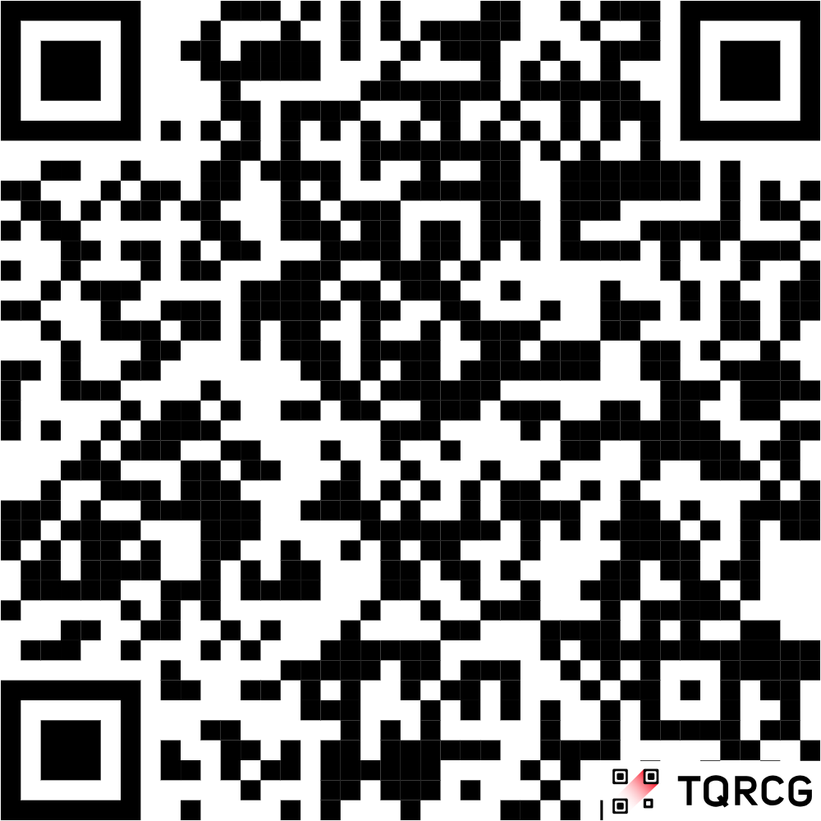
Scan Me!
Technologies Used: HTML, CSS, JavaScript

- Built a responsive portfolio website featuring project highlights, a contact form, and smooth navigation. Optimized for speed and SEO.

Technical Skills

- Programming Languages: Python, SQL
- Web Technologies: HTML, CSS, JavaScript, React, Node.js
- Database : MySQL
- Tools & Platforms: Git, GitHub, VS Code
- Concepts: REST APIs, Responsive Web Design, CRUD Operations, Front-End Optimization

Certifications

- React - Infosys Technologies Pvt Ltd, August 2024
- Python Developer - CuriosJr, June 2023
- MongoDB Developer - MongoDB University, July 2024
- Front End Development Libraries – freeCodeCamp, September 2025

Personal Traits

- Communication
- Teamwork
- Leadership
- Time Management
- Problem Solving
- Adaptability

Additional Details

- Ready to Relocate
- Familiar with Agile methodology, Git version control, and collaborative development
- Quick learner with a passion for exploring new frameworks and tools

Personal Profile
Date of birth : 27th April 2004 Father’s name : Mr.Mohammed Rafi Mother’s name : Mrs.Ramila Begam
Gender : Male
Nationality : INDIAN
Marital status : Single
Hobbies : Travelling different places, Reading books, Learn New Technologies, Cooking & Helping people
Languages Known : Tamil, English, Hindi
Address : 389,Hajiyar Nagar, Pudupattinam, Kalpakkam – 603102

Declaration
I hereby declare that all the details furnished here are true to the best of my knowledge and ever ready to furnish the certificates for confirmation.

Date : Signature
Place : Chennai (A.Mohammed Tharick)

